

Professional Lay-flat In-Ceiling Spot Speakers

Model # IC-125

Item #P1018000

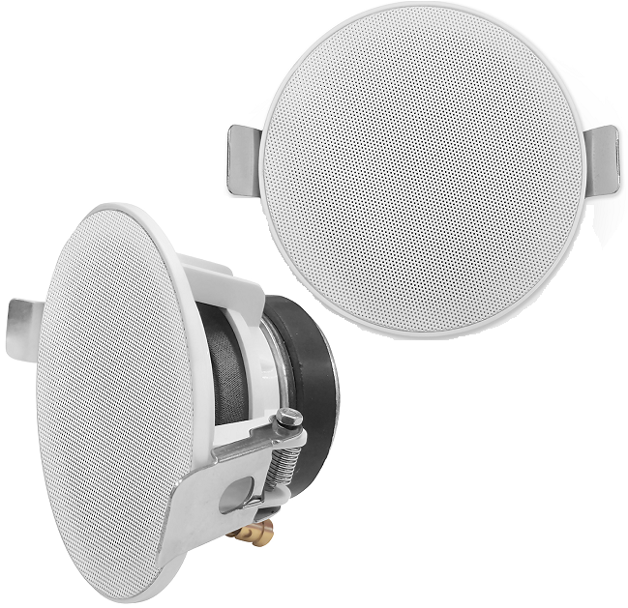

User Manual

&  
Safety Guide

Thank you for choosing Pure Acoustics. We hope you enjoy each and every use of this product. We suggest that you read this user manual carefully before primary use in order to utilize all of the features in functions installed. Please store it in a safe place for future reference and pass it on to the next owner.

Caution & Safety Guide:

Please power off the unit when not in use. If the unit will not be in use for an extended period, it is suggested that you disconnect the unit from its power source.

To prevent damage to the unit do not install in areas of extreme heat or in areas with direct exposure to sunlight.

Don’t install the unit in or near a place where it may come in contact with rain, moisture or other liquids.

Install the unit on a horizontal, flat and firm surface with good ventilation. Never block the speaker, blocking these vents may cause damage to the speaker as a result of overheating.

To clean the unit, simply wipe it down using a dry, soft cloth. The unit should never be cleaned chemicals or detergent.

In the rear occurrence of malfunction do not attempt to repair the unit on your own. Contact a certified service professional for a proper diagnosis and repair.

Caution: Dismantling the unit on your own is dangerous and may cause damage to your person or property and will void the warranty.





The lightning flash is intended to alert the user to the presence of dangerous voltage within the product’s enclosure and touching the internal components may result in an electric shock to your person.

The exclamation mark is intended to alert the user to the presence of important operating instructions.

To reduce the risk of electric shock or fire, do not remove the cabinet cover simply contact a service professional.

Features:

* Powerful well balanced sound throughout the room or space
* Gold tipped push down terminals and spring clasp provide an easy 1-2-3 DIY installation
* Lay-flat, rustproof aluminum grill blends to any wall or ceiling
* Multiple mounting options - in the ceiling or wall

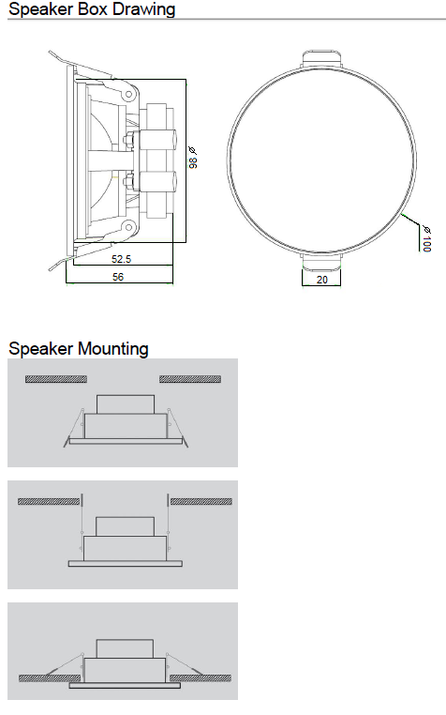

**Technical Specifications:**

Power Output: 50W

Frequency Response: 120Hz – 20 KHz

Sensitivity: 83dB + 3dB

Impedance: 8 Ohms

Woofer: 3”

Cutout dimension: 8.6 cm/3.4 inches

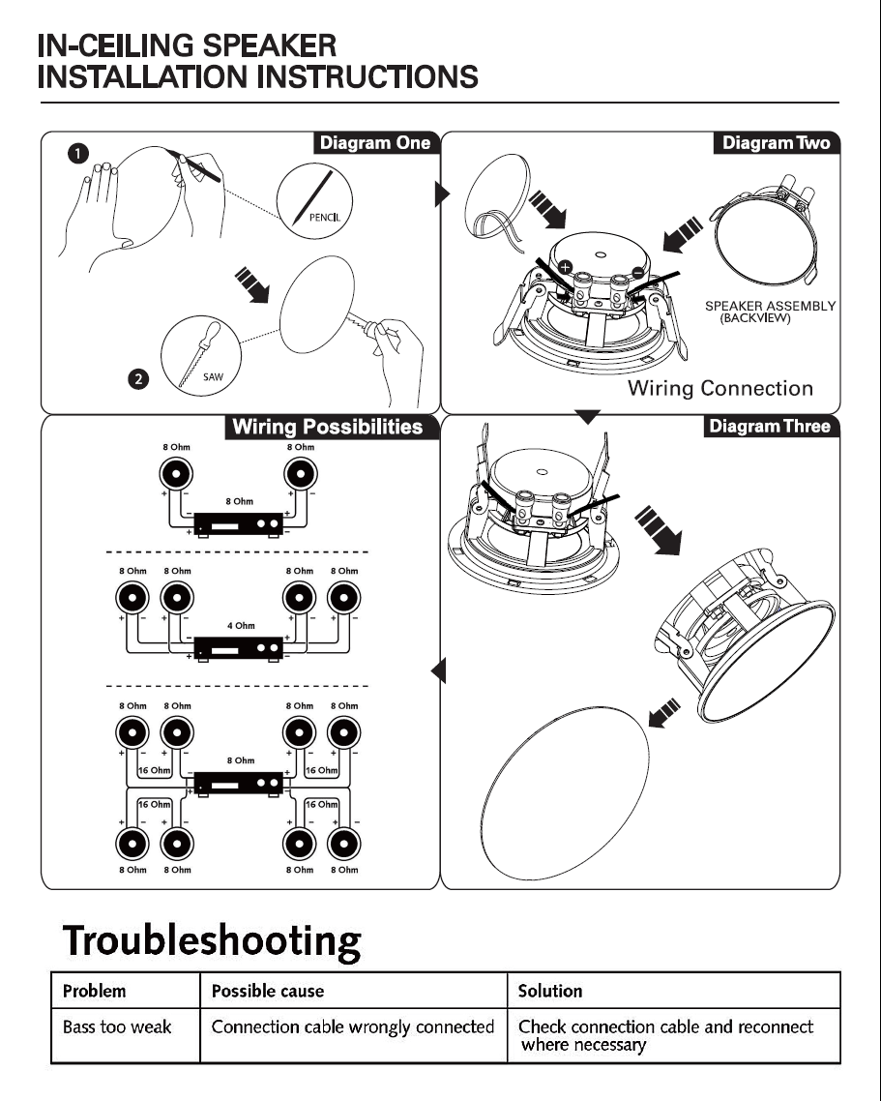

**Enjoy!**

**Once again we thank you for purchasing the IC-125 Professional Lay-flat In-Ceiling Spot Speakers. It is our hope that you enjoy this product every time it is put to use therefore, we suggest that you keep this user manual safe for future reference and so it may be passed on to the next owner.**

**Please feel free to visit our website** [**www.pure-acoustics.com**](http://www.pure-acoustics.com) **for information on this product as well as hundreds more**

