**WiFi Audio Receiver（CL-BOX）**

**WiFi 2.4G & 5G**

**Instruction Manual**

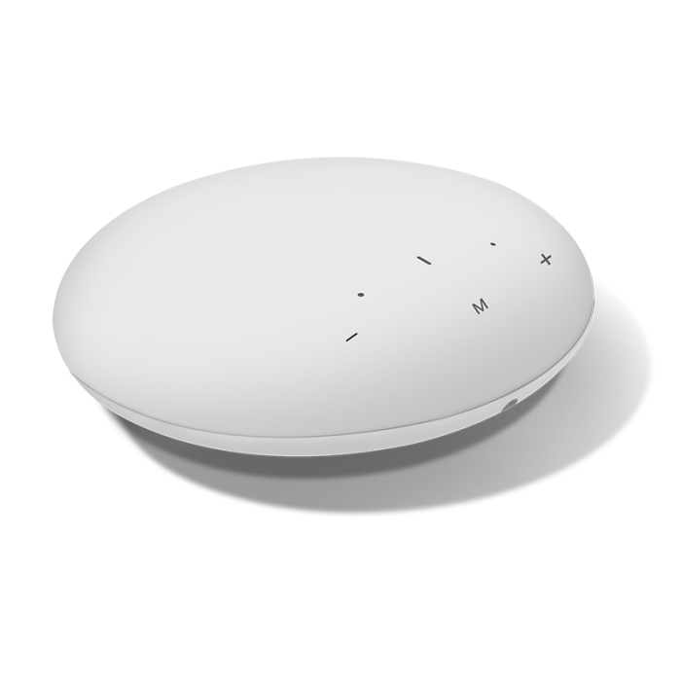

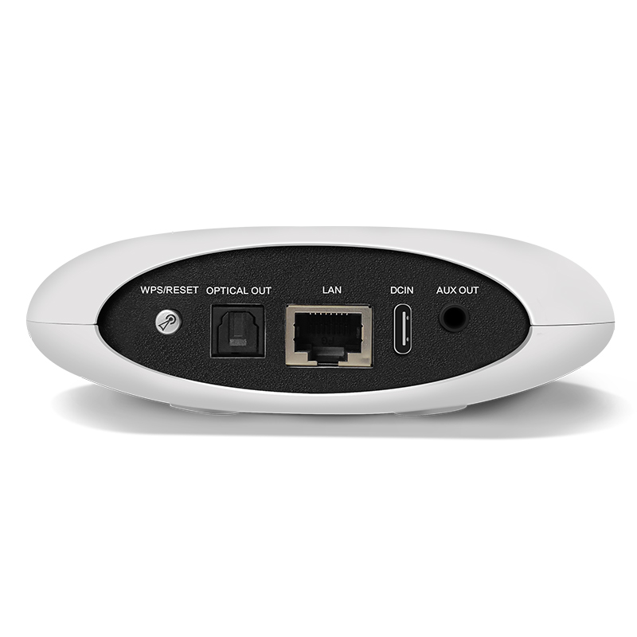

**Version 1.0**

**10, Nov. 2023**

**1.General information**

****CL-BOX**** is an innovative WiFi Audio Music Streaming Receiver that is able to turn your active speakers, soundbars and home theater speakers into a wireless streaming music system. It is designed with portable and cute size, without taking up much space. It offers you the easiest and most user-friendly experience for music streaming. You can enjoy high quality lossless music streamed wireless in multiple rooms.

****Features****

* Support WIFI 2.4G & 5G / Bluetooth / AUX / Optical fiber / LAN

* Support Audio system multi-room

* Support Airplay, DLNA

* Streaming music from Spotify, Tidal, Tunein, Napster, Amazon Music, Internet Radio, iHeartRadio etc.

1. **Technical parameters**

|  |  |  |
| --- | --- | --- |
| Audio I/O | | |
| Audio Input | NETWORK | WIFI 2.4G & 5G or LAN |
| BLUETOOTH | Bluetooth 5.0 |
| Audio Output | LINE OUT | Max 2V RMS Output |
| OPTICAL OUT | 48kHz/16Bit sample Output Max 0db |
| NETWORK | | |
| Ethernet In | RJ45 | Connect to router |
| Music Sources | | |
| Streaming Protocol | Spotify Connect, Tidal Connect, Airplay, DLNA, UPnP | |
| Online Music | Spotify, Tidal, Tunein, Napster, Amazon Music, Internet Radio, iHeartRadio | |
| Local Music | Mobile device music, NAS storage music files | |
| Multi Room  function | By APP to setup one BOX as master to sync music to other BOX | |
| General | | |
| Power | 5V - 1.5A | |
| Frequency | 20Hz-20kHz | |
| THD | 0.03% | |
| SNR | >95db | |
| Remote control | Infrared Remote Control | |

1. **Product structure description**

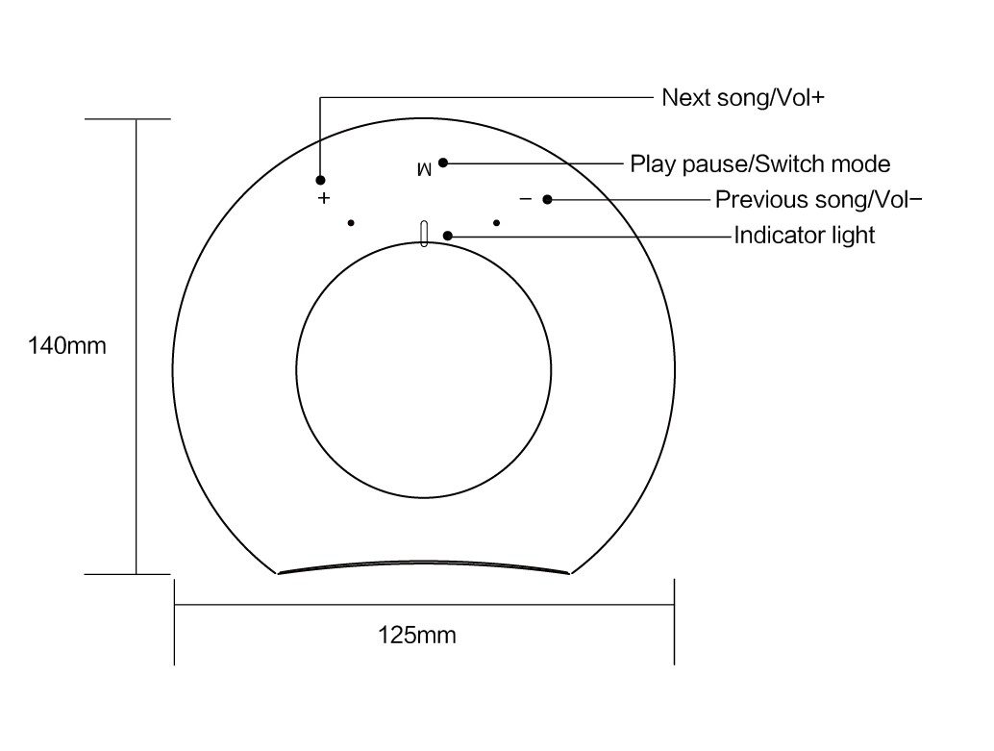

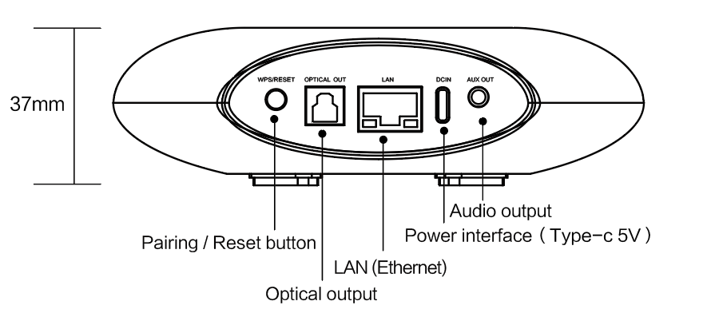

1. **Remote Control**

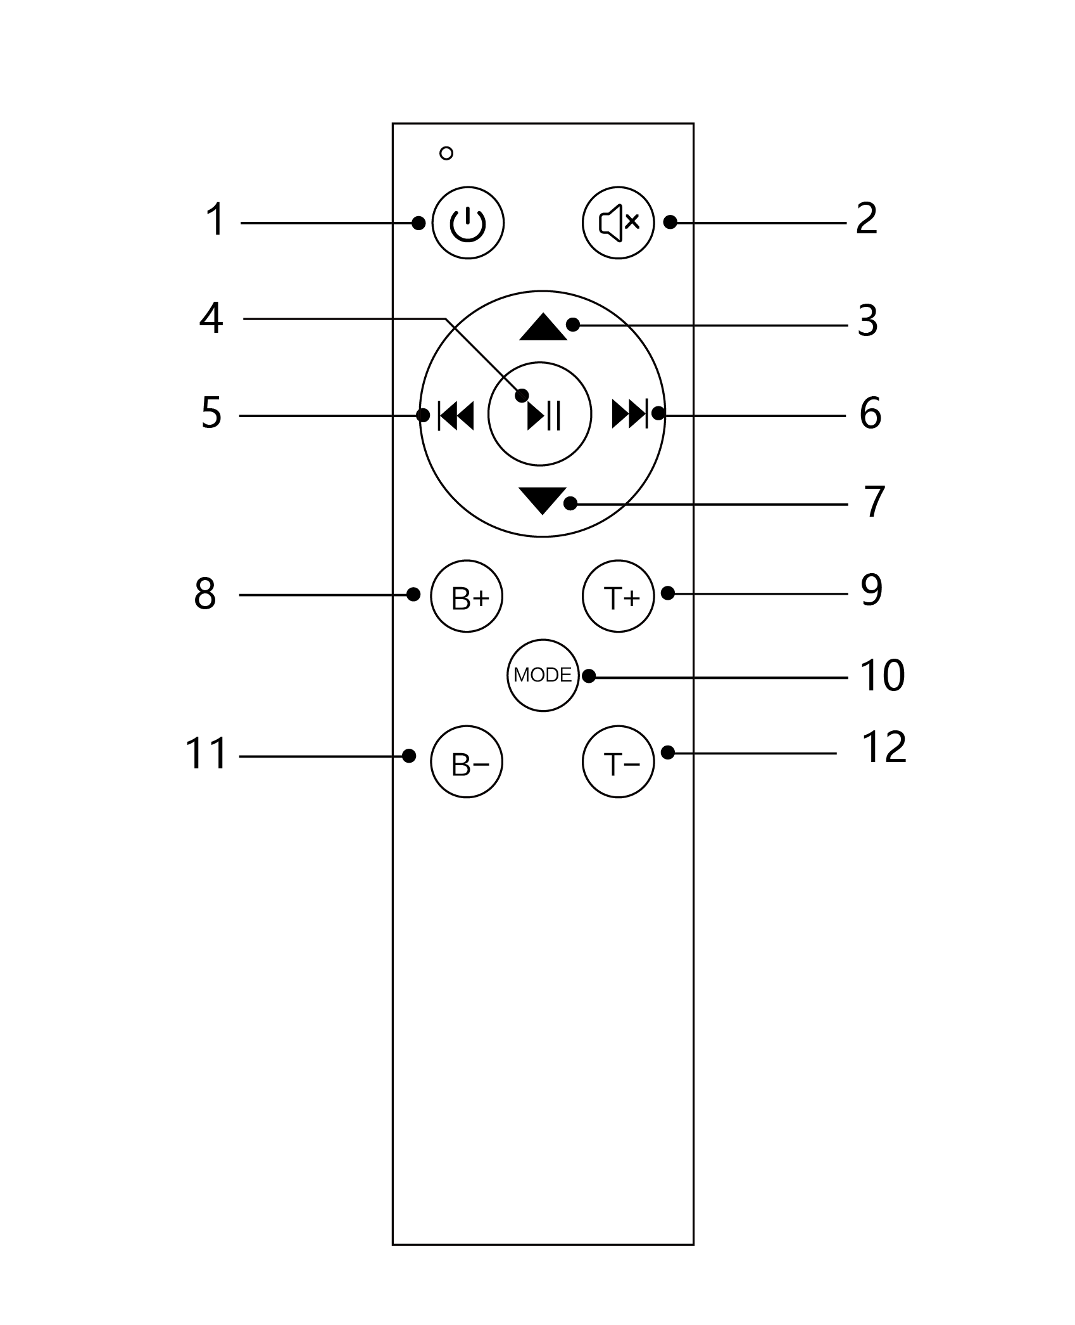

|  |  |  |
| --- | --- | --- |
| **No.** | **Name** | **Features** |
| 1 | Turn on / off | Turn on / off |
| 2 | Mute | Mute / Unmute |
| 3 | VOL+ | Vol+ |
| 4 | Play / Pause | Play / Pause |
| 5 | Previous song | Previous song |
| 6 | Next song | Next song |
| 7 | VOL- | Vol- |
| 8 | B+ | Bass+ |
| 9 | T+ | Treble+ |
| 10 | MODE | Mode switch |
| 11 | B- | Bass- |
| 12 | T- | Treble- |

1. **Instruction for use**

Before using this product, please read the following instructions carefully and operate the CL-BOX audio source receiver according to the instructions.

**5.1 Related control APP**

Please log in APP Store or Google play to download APP player: Audio System.



Audio System

**5.2 Start and signal connection**

Power on the audio source receiver and wait for the WiFi startup to complete. First find the device WiFi hotspot and connect it, then open the mobile APP and follow the APP prompts to connect the wireless network to the audio amplifier (as shown below). For more instructions on APP operation, please refer to Audio System User Operating Instructions Manual.

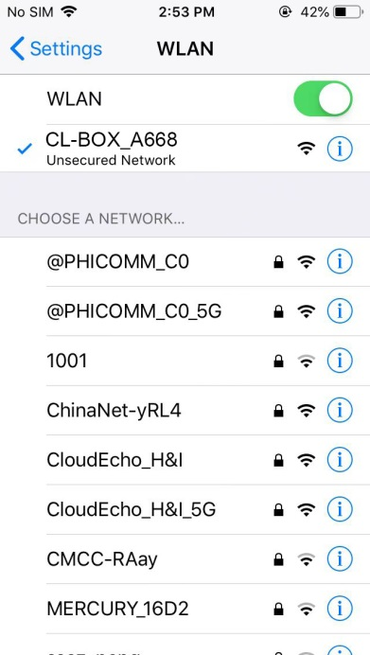 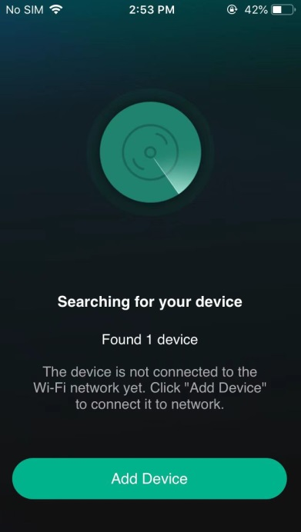 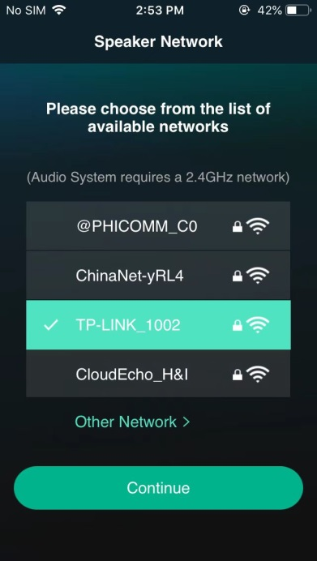

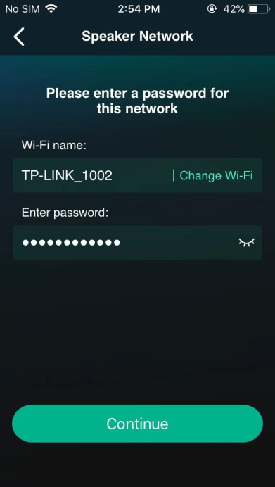 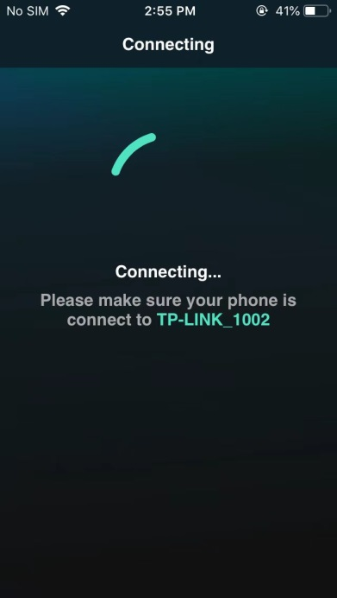 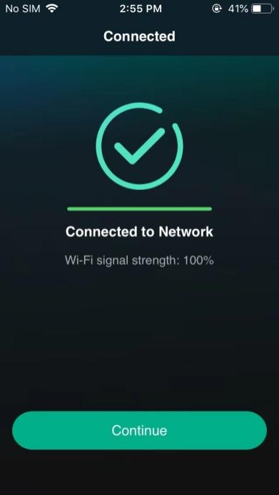

**5.3 Display and Operation**

**5.3.1 Display**

CL-BOX audio receiver indicator light is used to indicate the mode working status. Users can use CL-BOX according to the indicator light. The LED description is as follows：

|  |  |  |  |
| --- | --- | --- | --- |
| Indicator Light | Source | Situation | Description |
| White | WIFI | Flashes quickly | System is starting |
| Flashes Slowly | WiFi is waiting for pairing |
| Flashes very slowly | WiFi paired, no music was played |
| Light always on | WiFi audio is playing |
| Blue | Bluetooth | Flashes Slowly | Bluetooth is pairing |
| Flashes very slowly | Bluetooth paired, no music was played |
| Light always on | Bluetooth audio is playing |
| White or Blue | Source | Flashes fast once | Volume adjustment |
| Flashes fast twice | The loudest volume or the smallest volume |

**5.3.2 Operation Description**

* **Standby and Power on：**When CL-BOX is working, short press the standby button on the remote control to control CL-BOX to enter standby, stop the music, and turn off the Source indicator light; When CL-BOX is in standby, short press the standby button on the remote control to wake up and turn on the audio source receiver.
* **Touch button description：**There are 3 touch buttons on the CL-BOX. A light touch and a long touch can respectively operate volume up, volume down, the previous song, next song, pause/play and Source switching of the audio.

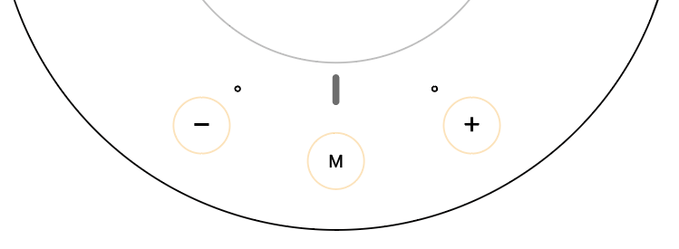

* **Source Switch：**When CL-BOX is working, short press the Mode button of the remote control or long press the M button to switch between WiFi and Bluetooth sources according to the remote control instructions; you can also directly select the Source in the APP (as shown below).

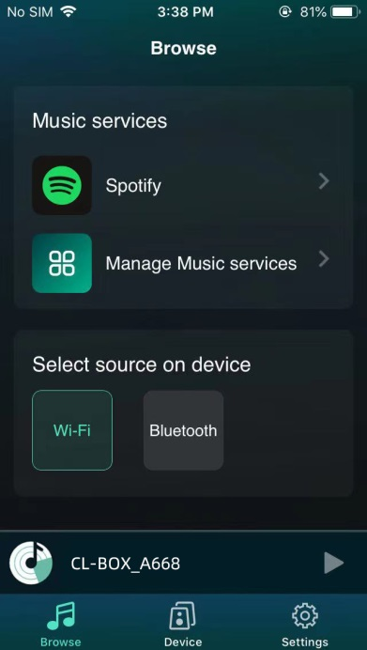

* Network configuration/pairing: When CL-BOX is working, short press the Reset button on the back of the device to release the WiFi hotspot and reconfigure the network or disconnect the current Bluetooth connection and re-pair.

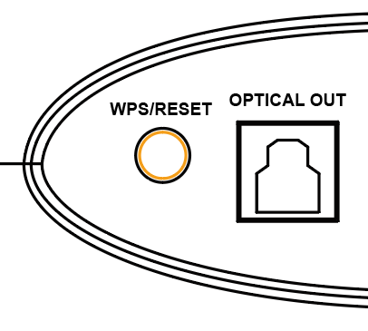

* Master volume adjustment: The CL-BOX master volume is divided into 32 levels, which can be adjusted through the remote control, short press of the touch button and APP.
* Audio operation: During CL-BOX audio playback, it supports the remote control and the APP to control the previous/next song, playback and pause, and you can also drag the playback progress in the APP.
* BASS/TREBLE adjustment instructions: When CL-BOX is working, short press the B+, B-, T+, and T- buttons on the remote control to adjust the BASS/TREBLE gain. There are 16 BASS/TREBLE levels available for adjustment. The gain Range [-7db, 8db], DSP sound effects will change with the adjustment.
* Reset and reset: While CL-BOX is working, press and hold the Reset button on the back of the device for 3 seconds to restore CL-BOX to factory settings, reset volume of CL-BOX , BASS gain, and TREBLE gain, and clear wireless network connection information.



1. **Parts list**

|  |  |  |
| --- | --- | --- |
| **No.** | **Name** | **Qty** |
| 1 | CL-BOX audio streamer | 1 Pcs |
| 2 | Power Adapter | 1 Pcs |
| 3 | Power cord (A to C) | 1 Pcs |
| 4 | 3.5mm-3.5mmCable | 1 Pcs |
| 5 | Remote control | 1 Pcs |